Practical 1:Introduction and Contribution to Wikipedia.
A)Description About Wikipedia And Its Features.
- The creators of Wikipedia are Jimmy Wales and Larry Sanger.
- The name Wikipedia is derived from a Hawaiian work "wiki" meaning fast,quick.It was launched on January 15,2001.
- Wikipedia is an online free-content encyclopedia project helping to create a world in which everyone can freely share in the sum of all knowledge. It is supported by the Wikimedia Foundation and based on a model of freely editable content.
Features of Wikipedia are:-
- Updation of content
- Edit (users can edit content)
- Creating New Pages
- Editing them
- linking of pages
- View form of pages:- list,structure etc.

Wikipedia is multiluinguial platform
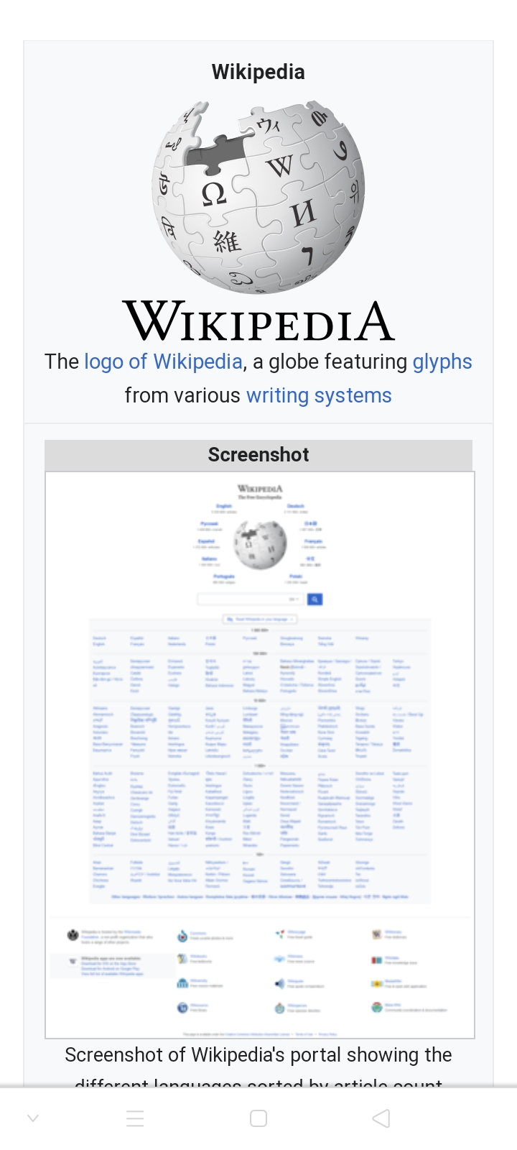
B) Creating Account On Wikipedia.
1) Search for www.wikipedia.org on your web browser.
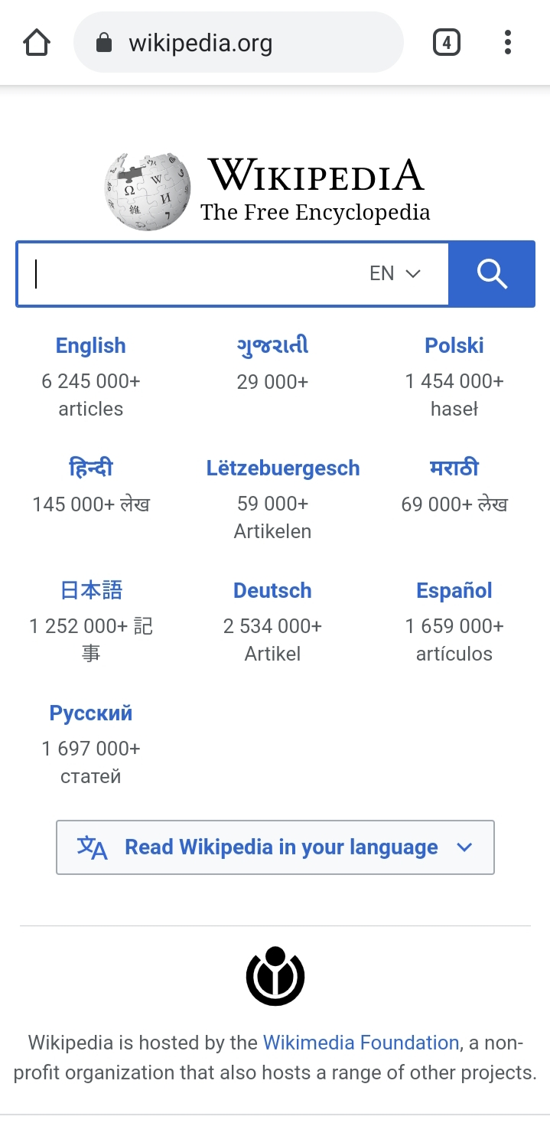
Mobile View.

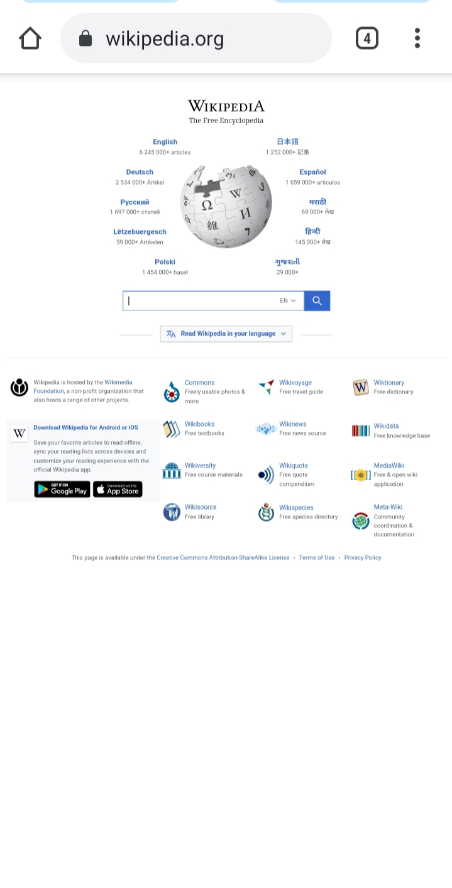
B)Desktop View.
2)Select the language you are comfortable with and search for the topic or content you are looking for in the search bar.
3)After the page loades select on three lines ,which is on upper left side of and beside wikipedia logo.
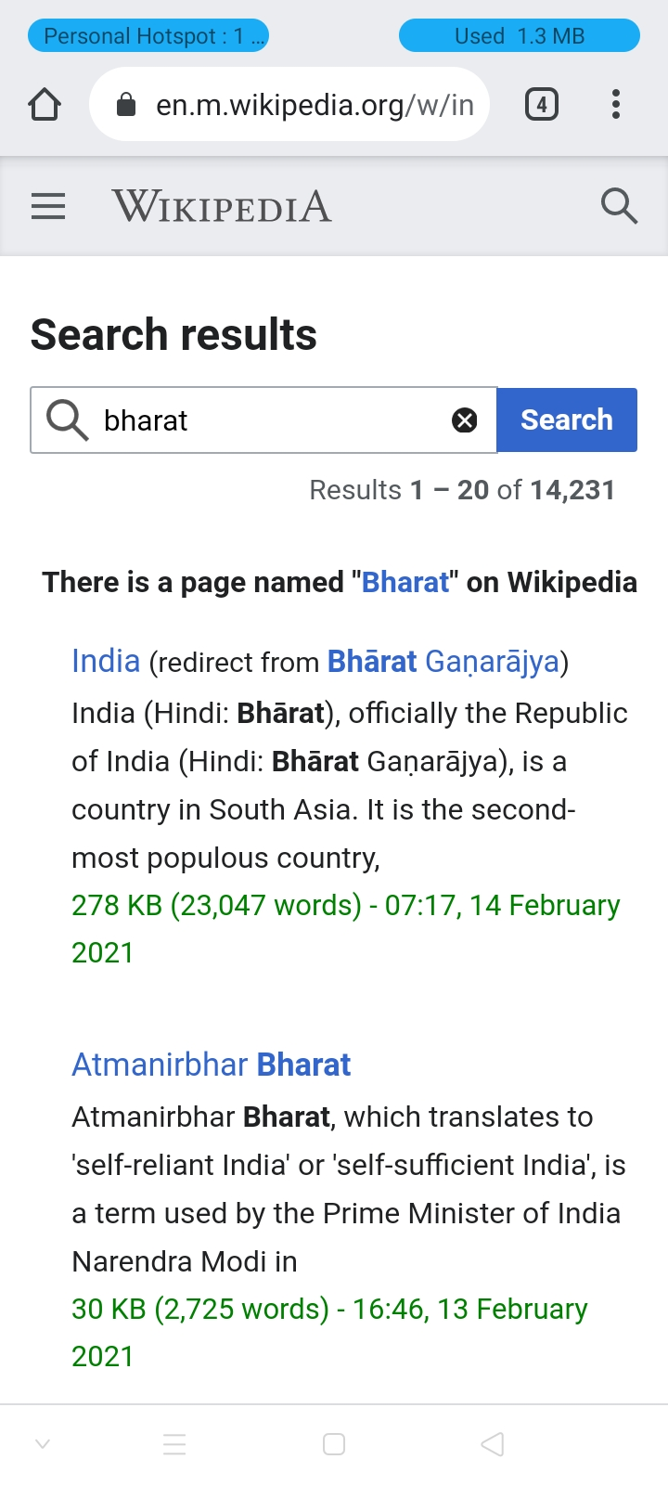
A)Mobile View

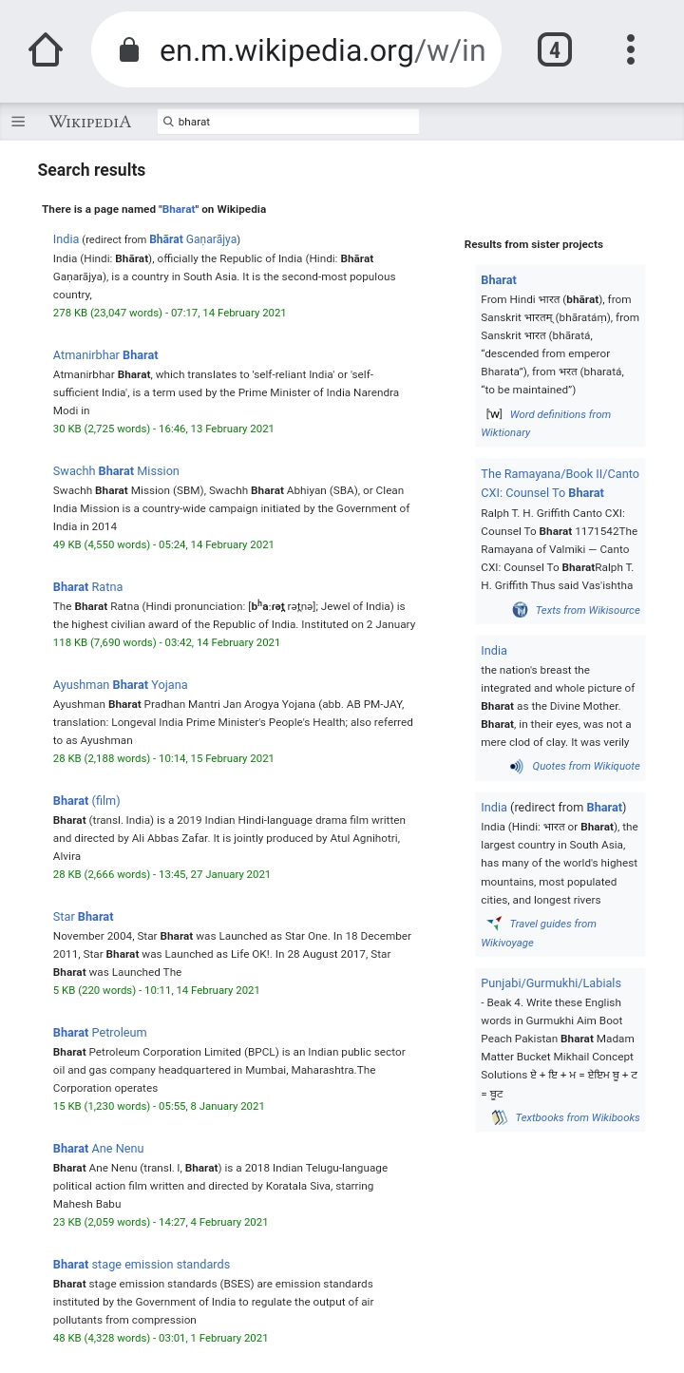
B)Desktop View
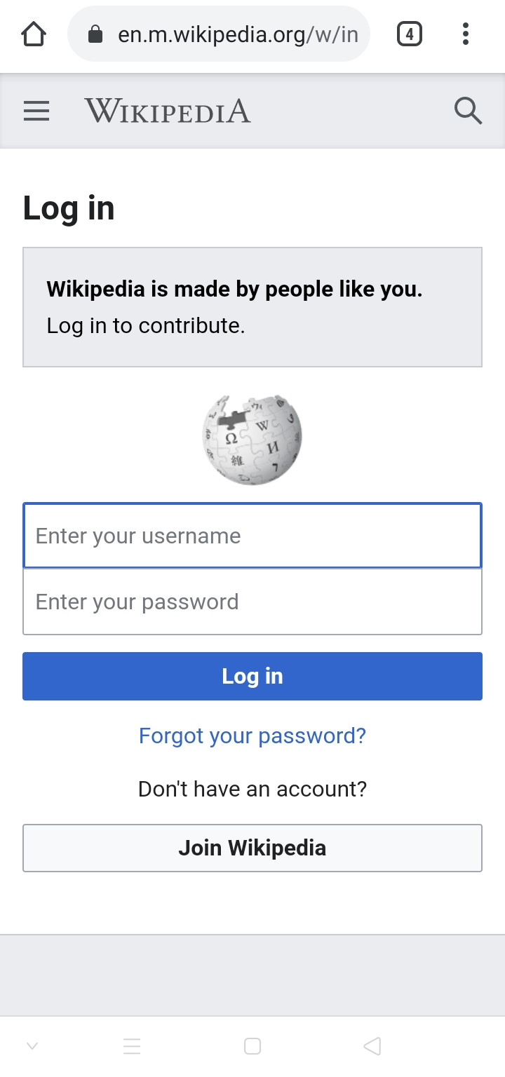
4)After clicking there,click on login. (4th option).
5)Login page will appear, then click on JOIN WIKIPEDIA.
A)Mobile View.
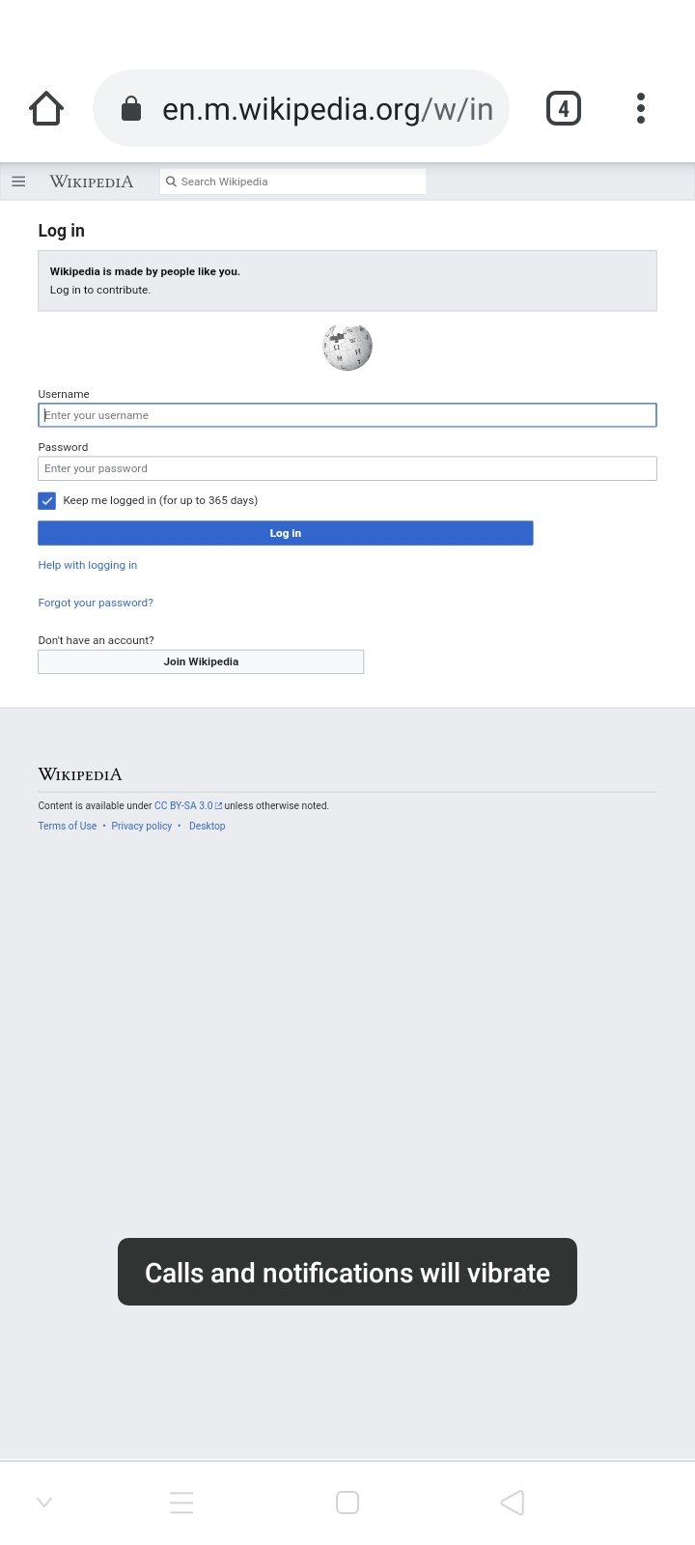
B)Desktop View
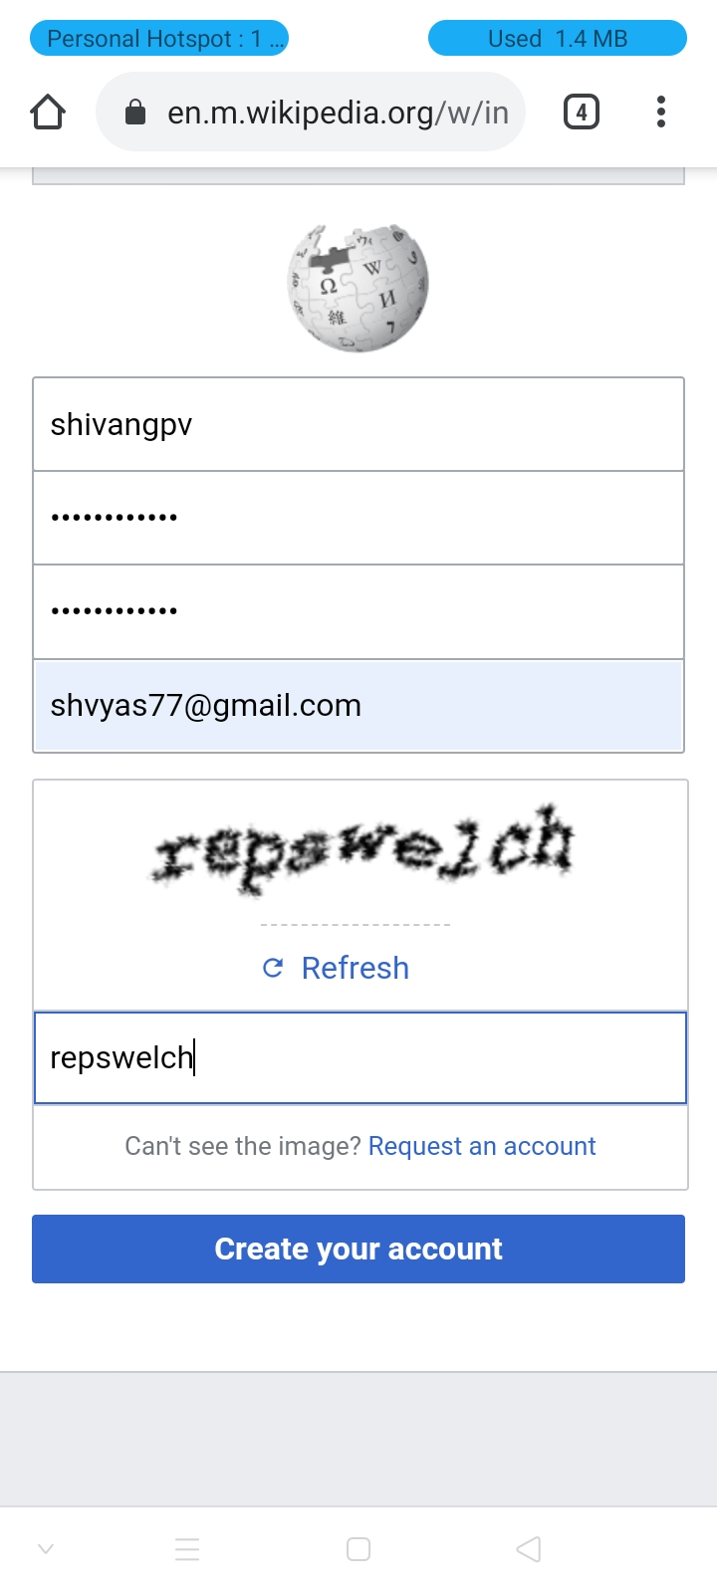
5)When you click on join wikipedia you will be redirected to a sign up page.
A)Mobile View

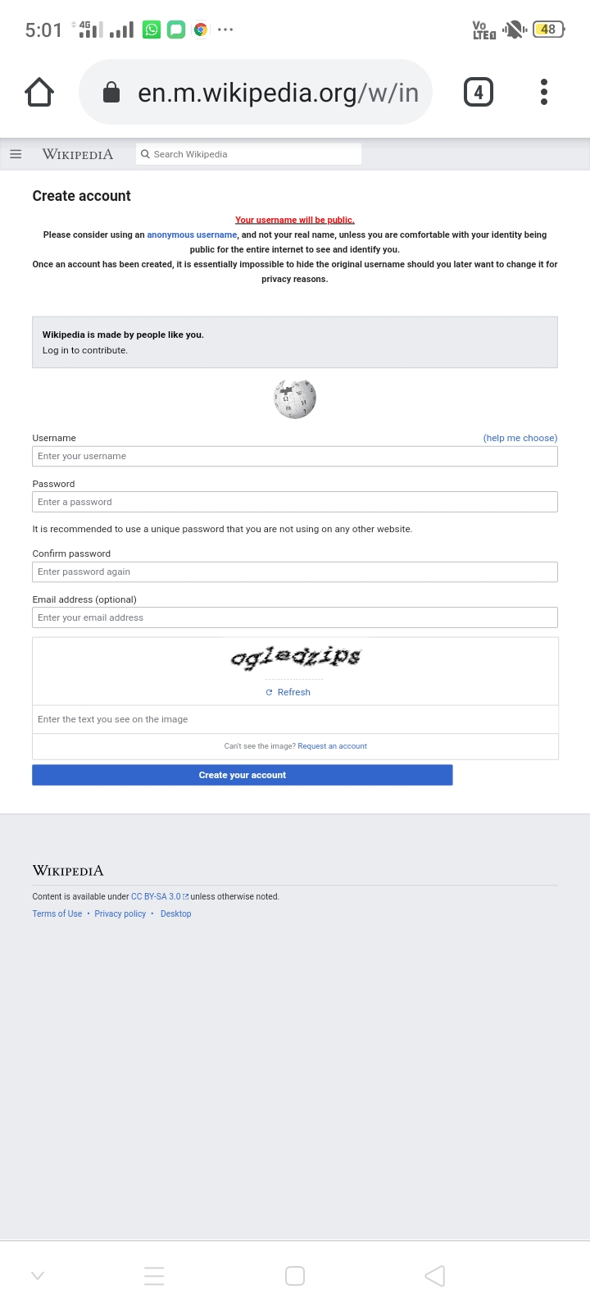
B)Desktop view
6) You have to enter,your desired username,and password followed with email id,for security purpose it will ask you for type the words you see in the box(captcha).
Enter those words properly.
7)After following all these steps click on create account.
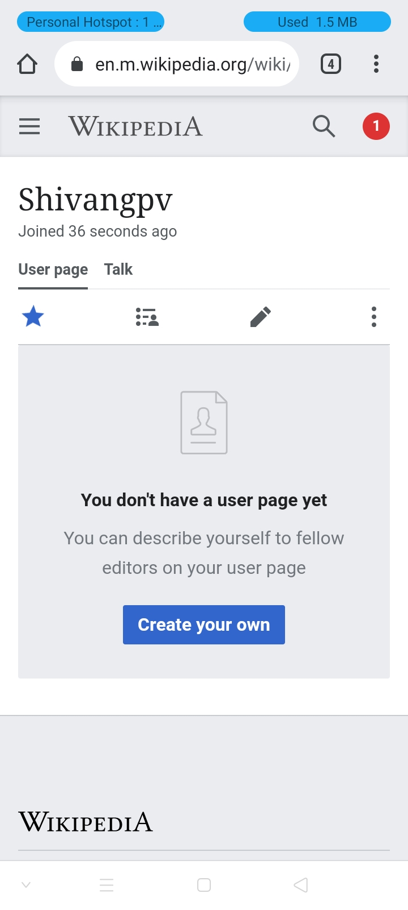
Account will be created ,if username is taken it will show error,and ask you to enter new user name.
A)Mobile View
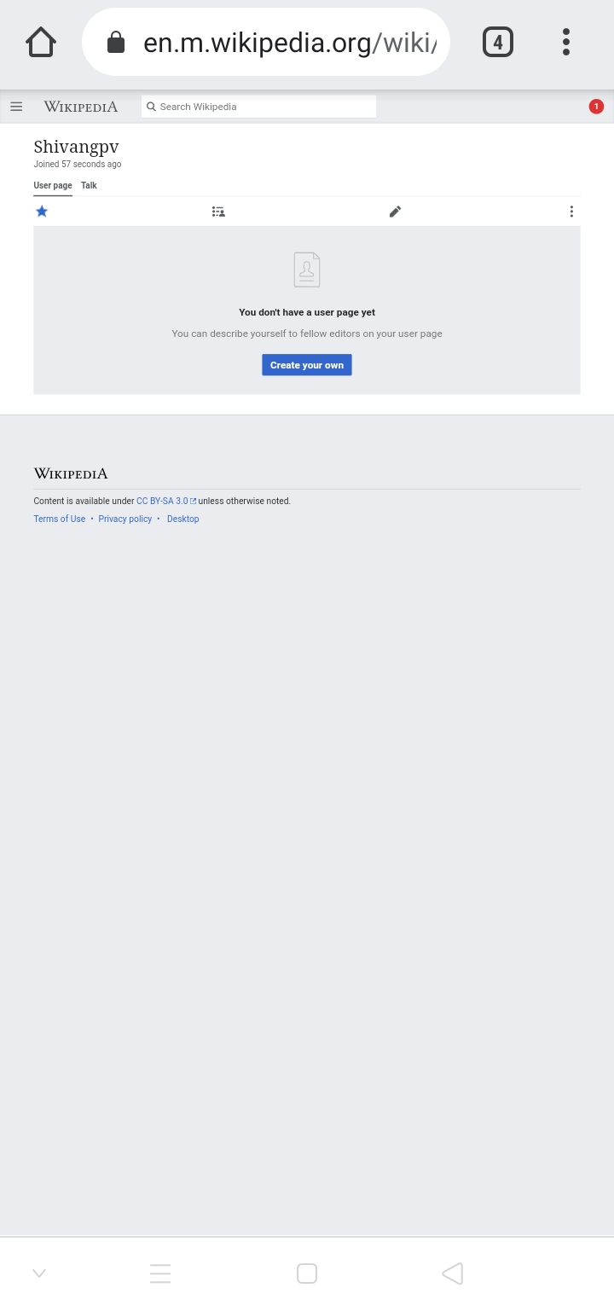
B)Desktop View
Your account has been created successfully.

C) Creating page on wikipedia.
1) Click on create new page.
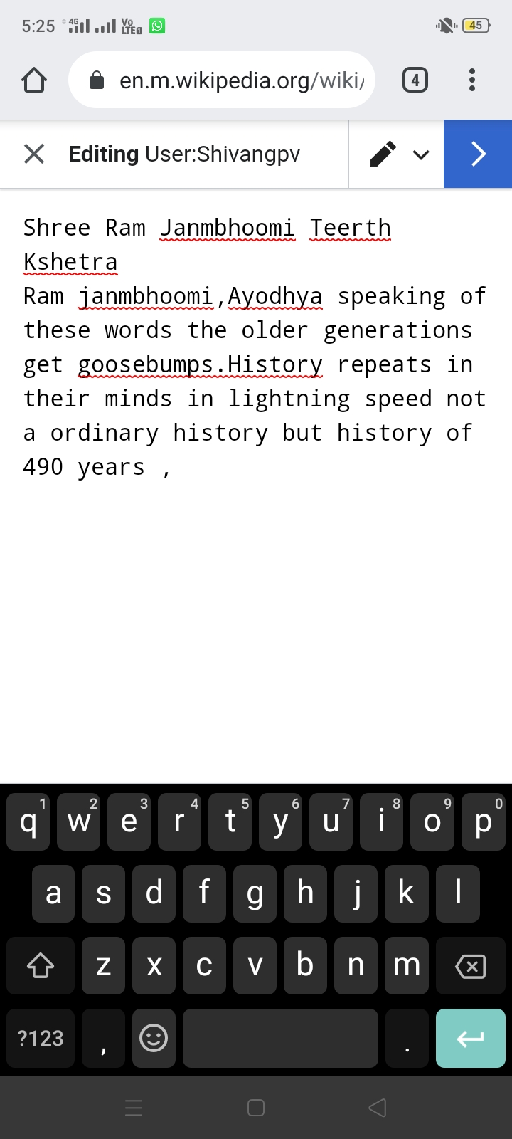
A text box will be provided there ,write your content and when you click on upper right blue icon it will ask you to right summary.
1)Mobile Vieew
B)Desktop View
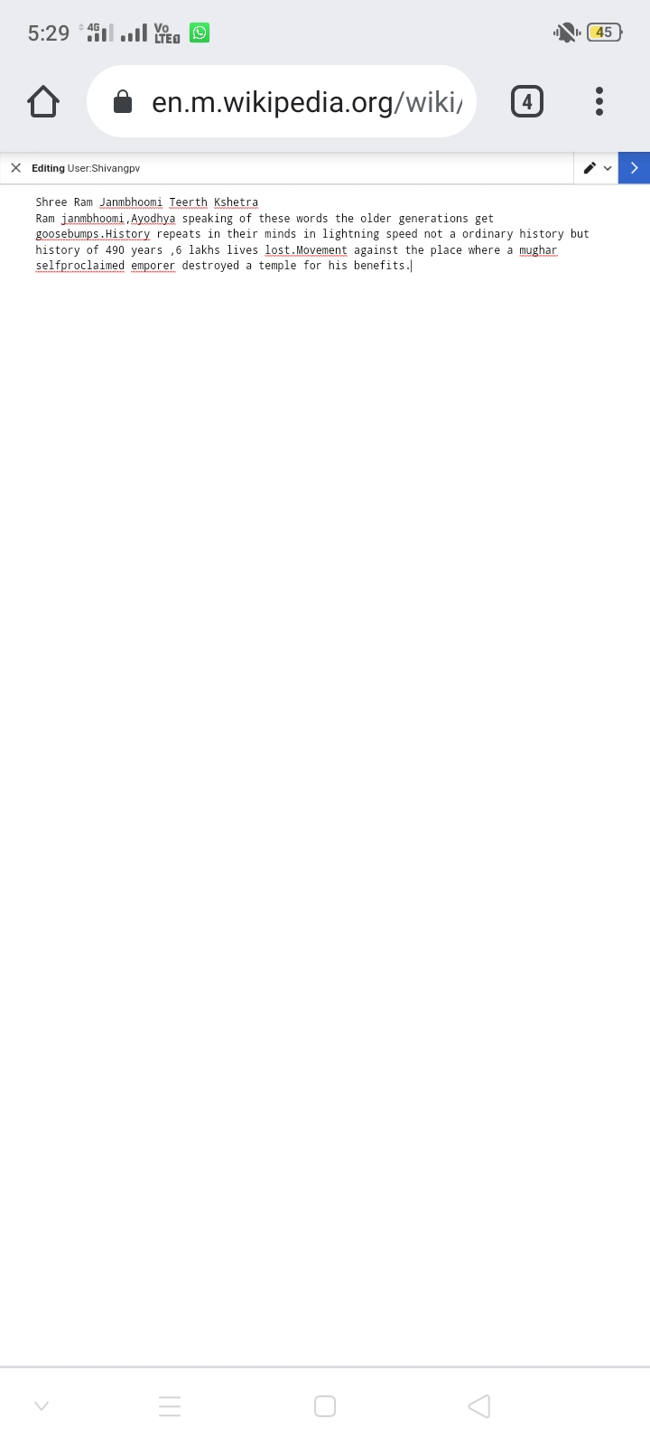
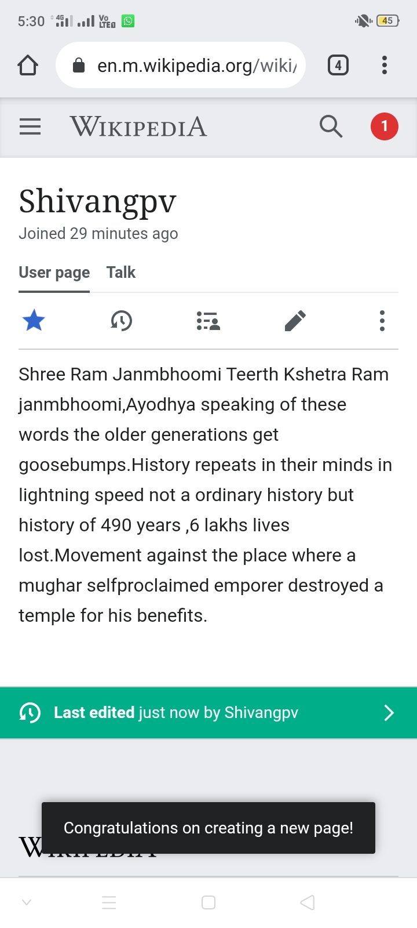
Content has been uploaded on the new page created.
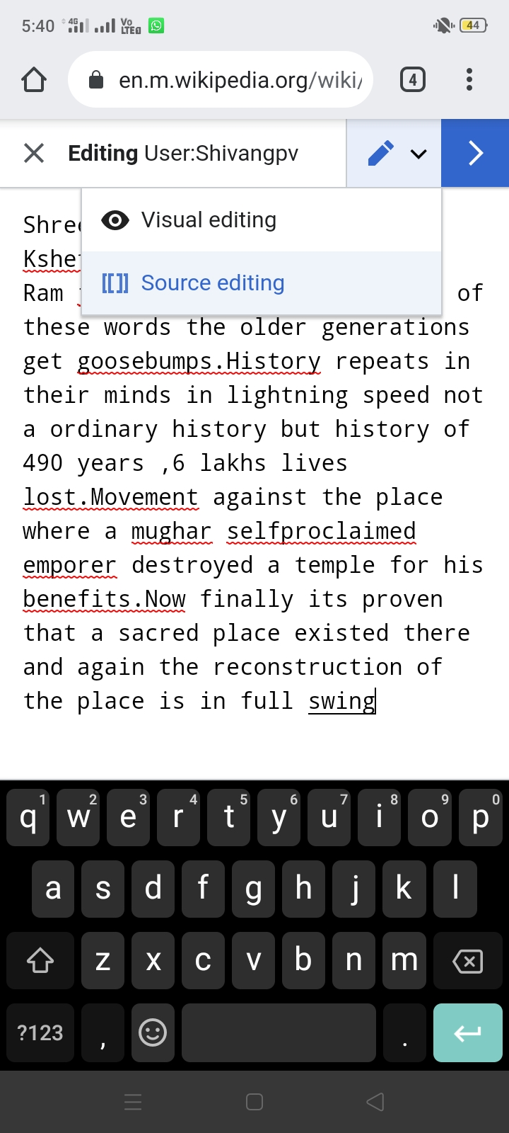
D) Edit page on wikipedia.
1)Click on the pencil mark
Two options will be there
Visual editing and source editing
In visual editing you can edit the text style shape etc.
In source editing we edit the content of the information written.

THESE ARE THE STEPS TO FOLLOW.
Dont use wiki for entertainment purpose,dont edit someones hard word,use appropriate language.
THANK YOU

